 How To Print Recharge Card in Nigeria

Using VMTECH PIN EXTRACTOR

Compiled By VM Technologies LTD.

To Get The Software, Kindly Download it at www.vmtechonline.com

**ABOUT VMTECH PIN EXTRACTOR**

“**VM Tech Pin Extractor**” software enables everyone to print recharge voucher of all networks (MTN, 9mobile, Glo, Airtel, Visafone and Starcomms)

using a computer or phone and printer. It works with e-pins purchased **From Our Company and other e-pin dealers in** Nigeria. (We sell cheapest price of e-pin in Nigeria)

“VM Tech Pin Extractor” has a user friendly interface with easy-to-use modules that even a novice will understand.

**STEP 1**

Buy e-pins you want to print from us and save the file somewhere on your computer. You can create a PIN folder in your local disk-C of your PC or flash drive and save it there.

The e-pins might be encrypted in text or PDF files. It would be protected with password for security reasons. You would get the password at the point of purchase of the e-pins, so you can use it to open the e-pin file.

Kindly note that for training purpose, VM Tech Pin Extractor uses a sample e-pins file when

Teaching people how to use the software in printing recharge cards.

**STEP 2**

Connect your printer to your computer and ensure it is working fine.

You can use any printer but laserjet Printer is recommended because you will be wasting a lot of money buying ink-cartridges for deskjet printers.

**STEP 3**

Download VM TECH PIN EXTRACTOR on your computer. **Install** and **Activate** it.

You can download it at: www.vmtechonline.com

Please note the software will NOT work on smart phones. Software is for computer only. You can use any phone to print recharge card only on our e-pin portal.

After successful installation, you should notice the “VMTECH PIN EXTRACTOR” Short cut on your desktop.

Locate and Click on the Short cut of the VM TECH PIN EXTRACTOR SOFTWARE on your Desktop as shown below

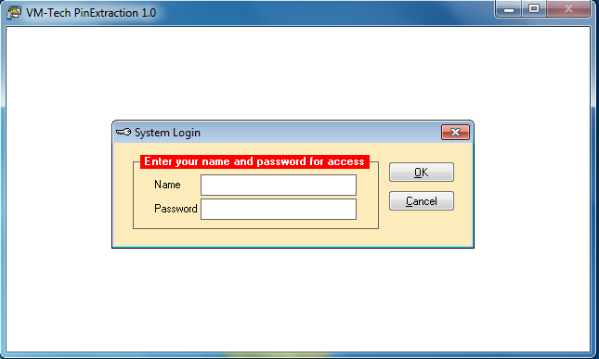

Type “**ADMIN”** in the space provided for name and don’t type anything in the space for password as shown below.

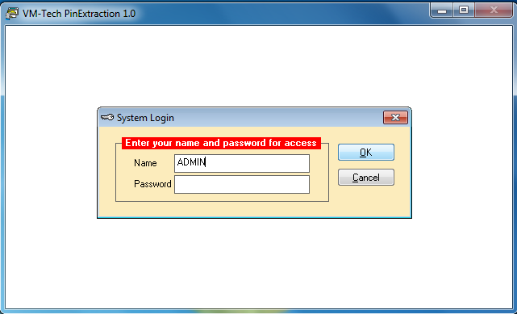

Then click on the **“OK”** button and the next page will appear.

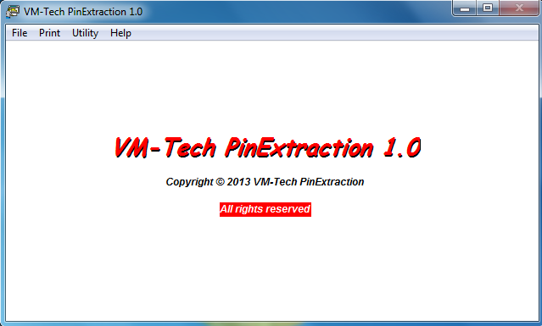

In this page you see the **File**, **Print**, **Utility** and **Help**.

**Help**: This Contains Our Contact Phone Numbers and Address.

When you click on “**File”,** it will produce the following dropdown.

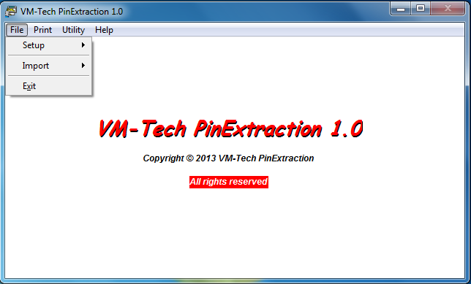

The first thing is “**SetUp”** which is used to setup your business name and address so they can appear on the recharge card when you print as shown below.

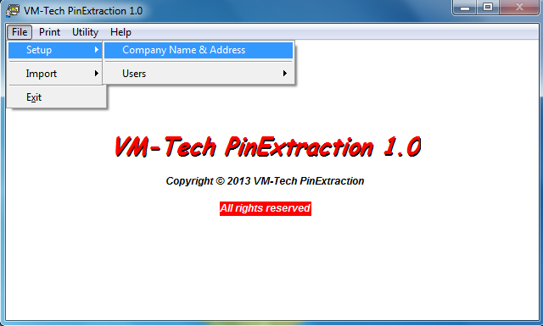

Click on “**Company Name & Address”**

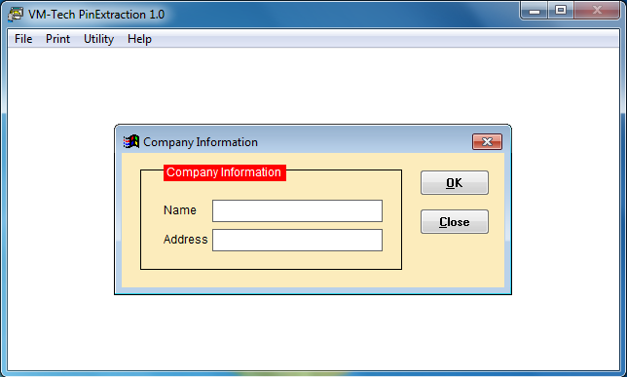

Type your company’s name and address in the spaces provided and click on ok.

**Import**: this is used to select the network you want to process and print. Click on the “**Import”** button under file and the following dropdown will appear.

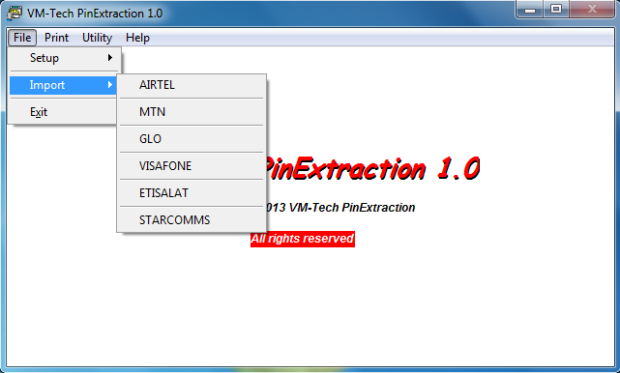

Click on the network you want to extract and the next page will appear.

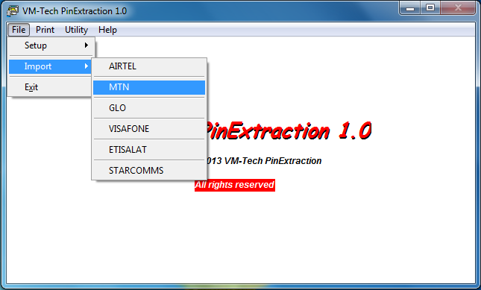

MTN was clicked in this case.

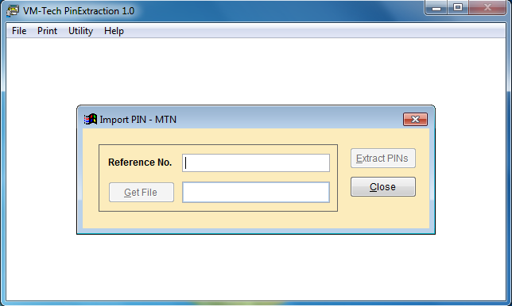

Type anything in the space provided for **Reference No**. and click on “**Get File”**

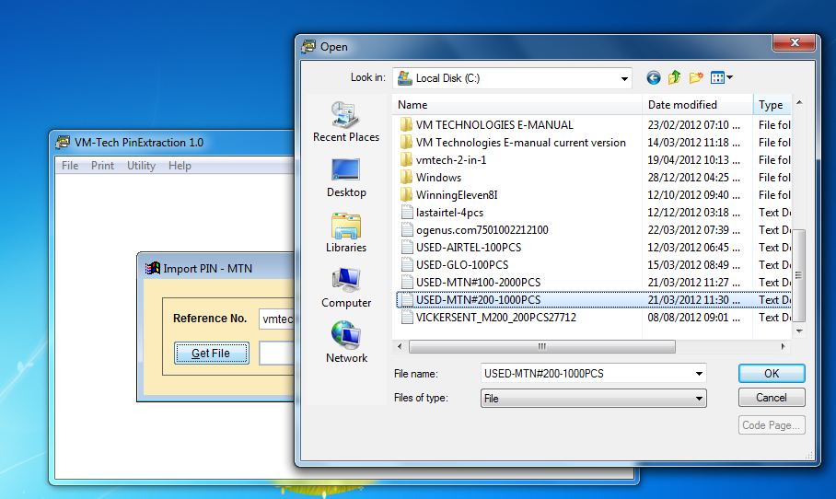

Select the network e-pin file you want to print and click **“OK”**

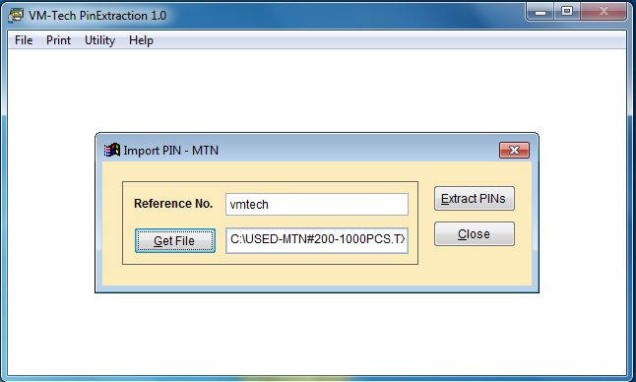

Click on “**Extract PINs”**

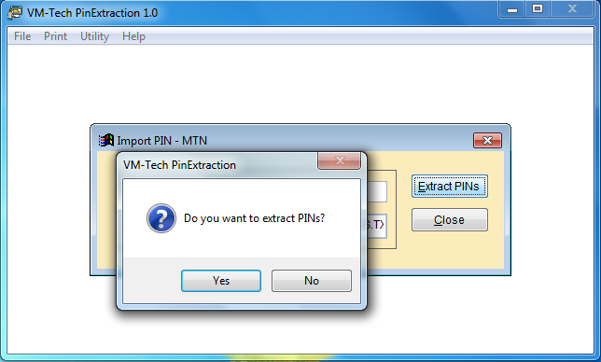

Click on “**Yes”**

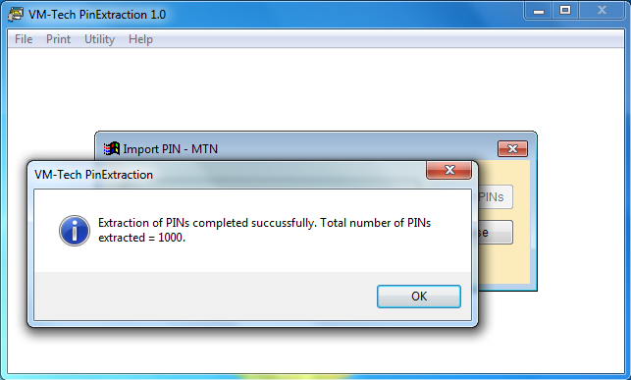

Click on “**OK”**

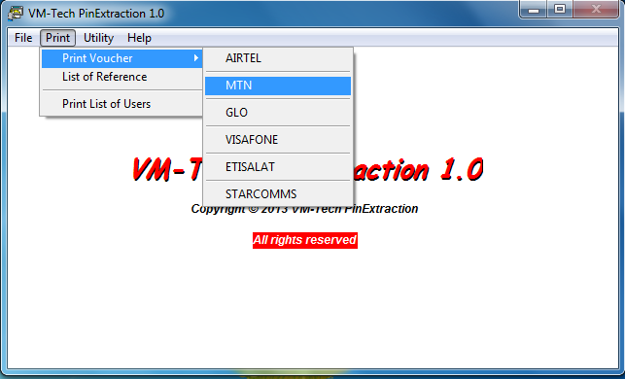

Then click on “**Close”**. Then go to print and select the same network as shown below.

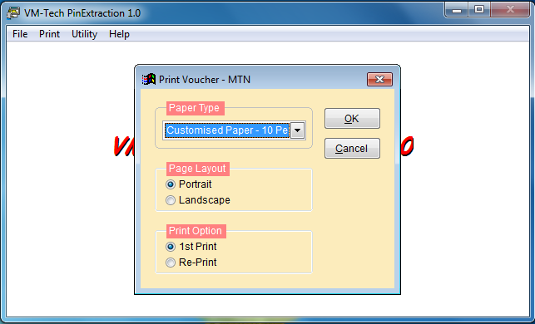

Click on dropdown arrow head by customized paper and select either **Plain Paper 10 Per Page** or **Plain Paper 20 Per Page**

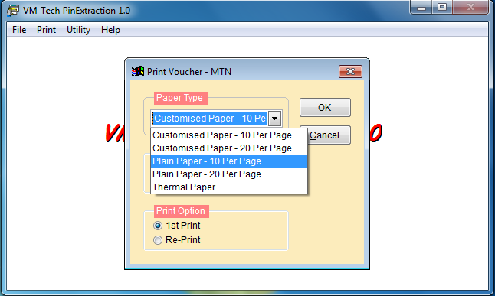

Select either **Plain Paper 10 per page** or **Plain Paper 20 per page.**

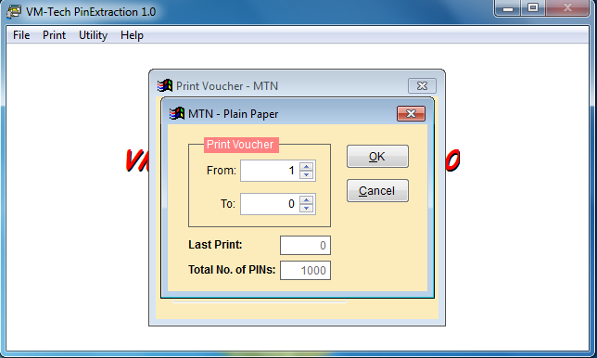

Select the total number you want to print and click on “**OK”**.

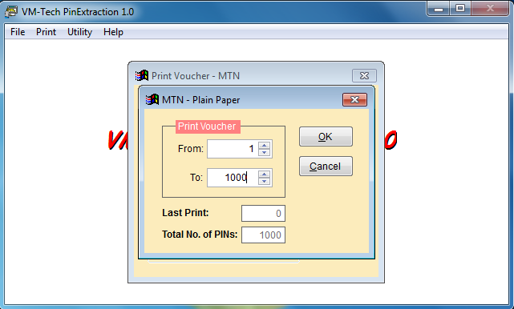

Select the total number you want to print and click on OK.

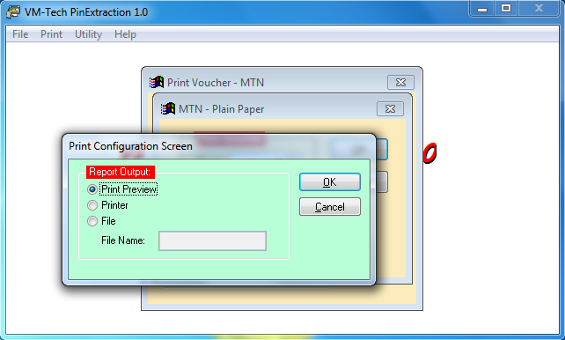

If you just want to see the cards on your computer, you click on print preview else, if your printer is connected you click on printer and print out your cards.

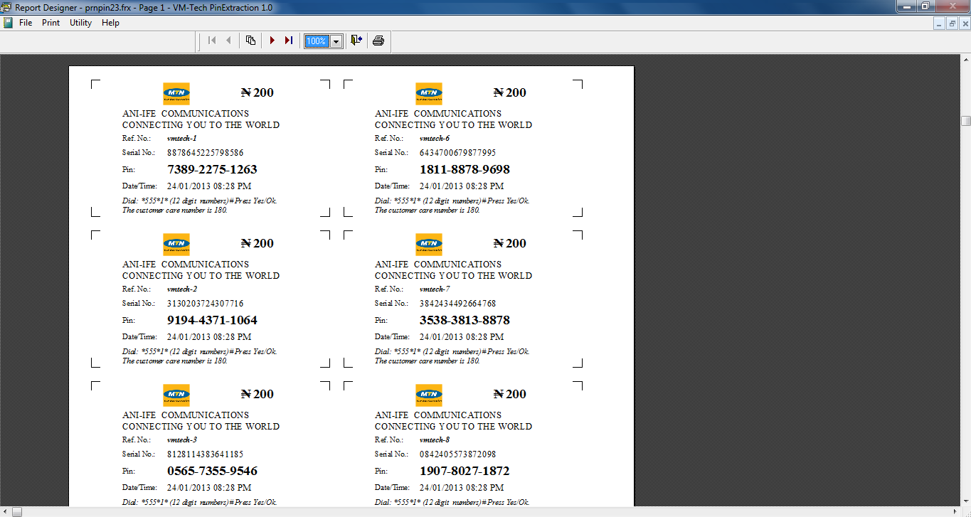

**Click on the printer icon**

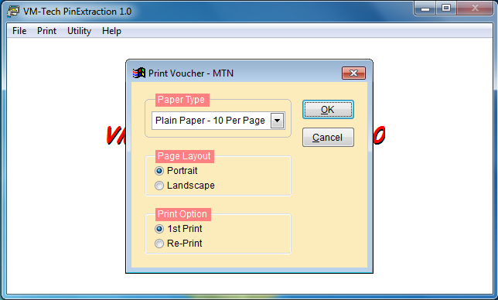

Click on either the red button **“X” or** the button “**Cancel”.** Do not click on **OK**

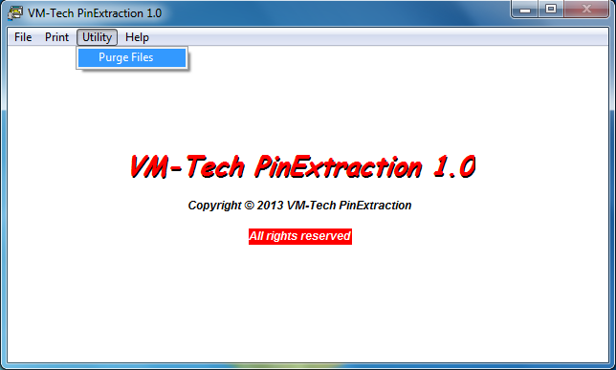

Go to “**Utility”** and click on “**Purge Files”**. Note you must use it after printing.

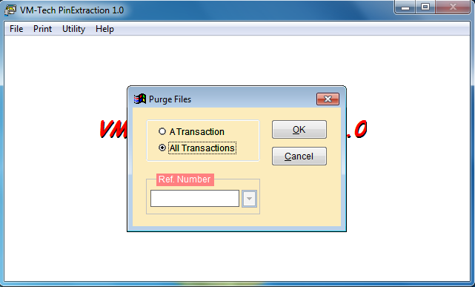

Select “**All Transactions”** and click on **“OK”.**

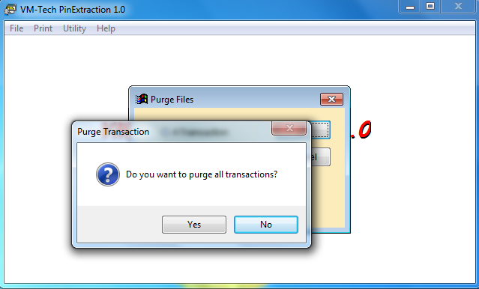

Select “**Yes”**

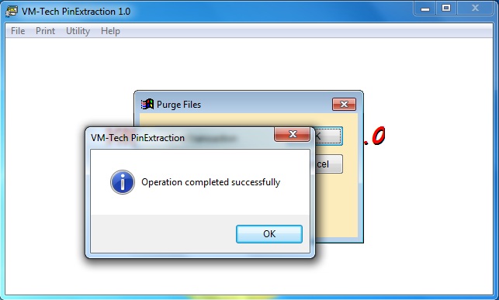

Click **“OK”**

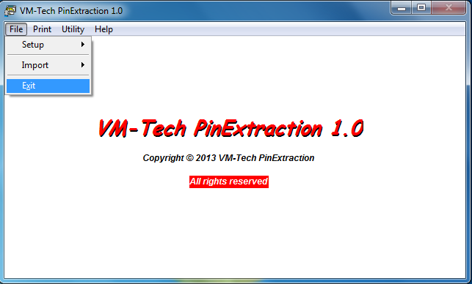

Select “**Exit”** to close the application

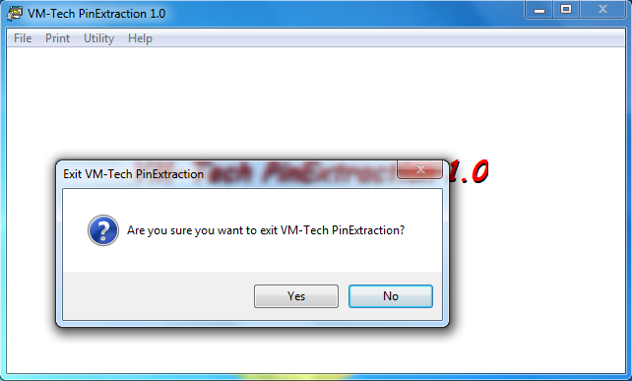

Select **“Yes”**